**Deployment of Virtual Machine**

**Steps to Create Linux/Windows Virtual Machine (Manually):**

* Subscription.
* Resource group.

**Project Details:**

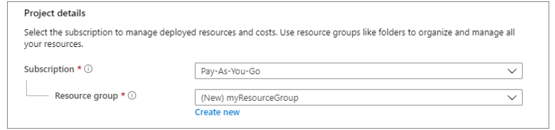

**Configure Instance Settings**:

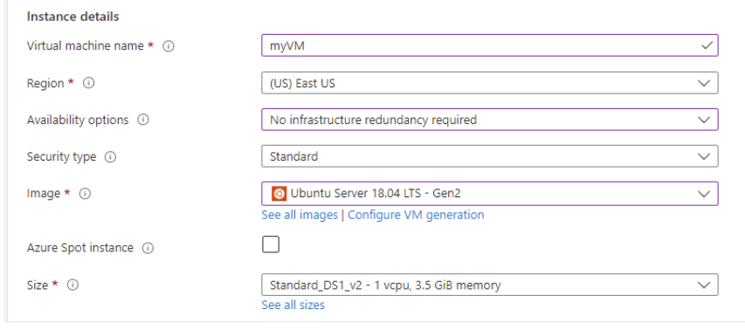

* Virtual machine name.
* Region - Select a location close to you.
* Availability options - Select No infrastructure redundancy required.
* Image - From the dropdown list, select Ubuntu Server 18.04 LTS - Gen2.
* Size - Standard D2s v3. This option gives you two vCPUs with 8 GB of RAM.

**Administrator account:**

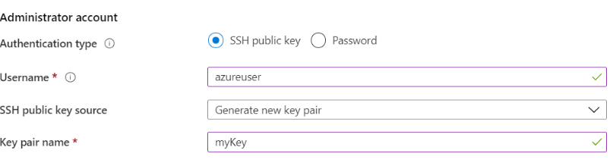

* Authentication type - SSH public key
* Username - Enter a name you'll use to sign in with SSH. Make a note of it.
* SSH public key source - Use existing key stored in Azure.
* Key pair name - Paste the SSH key from your public key file you created in the previous unit.

**Inbound Rules:**

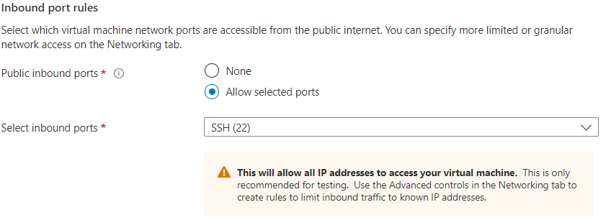

* Public inbound ports - None
* Select inbound ports - Select SSH (22) from the dropdown list.

**Configure Disk:**

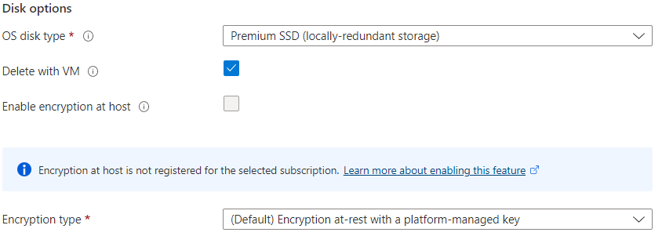

* OS disk type - Premium SSD.
* Encryption type - (Default) Encryption at-rest with a platform-managed key.
* Data Disk - Create and attach a new disk.

**Configure the Network:**

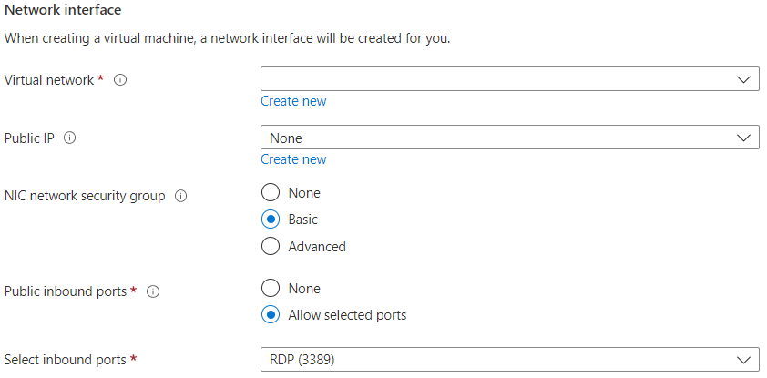

* Virtual Network – Use the existing Vnet.
* Subnet - First subnet to subdivide the address space - it must fit within the defined address space. After the Vnet is created, you can add more subnets.
* Public IP – None.
* NIC Network Security Group – Basic.
* Public Inbound Port – None.
* Select Inbound Port – SSH (22).

Leave the remaining defaults and then select the **Review + create** button at the bottom of the page.